NFL ROSTER PRO

LOGIN

Username

●●●●●●●●

LOGIN

VIEW PLAYERS

CREATE ROSTER

EXIT

VIEW PLAYERS

CREATE ROSTER

EXIT

Last First | Team

Last First | Team

Last First | Team

Last First | Team

Click a name to see player stats

Stats for selected players shows here

Menu moves down, show player filters

**STORYBOARD FOR FINAL PROJECT**

VIEW PLAYERS

CREATE ROSTER

EXIT

Last First | Team

Save Current Roster  
Export Roster to Excel  
Edit Saved Roster

Last First | Team

Last First | Team

Last First | Team

Last First | Team

Dynamically load the player stats when hovering mouse over name. Show in tooltip style box next to mouse…

or, use similar box as the “Create Roster” screen



VIEW PLAYERS

CREATE ROSTER

EXIT

Save New Roster  
Export Roster to Excel  
Load Saved Roster

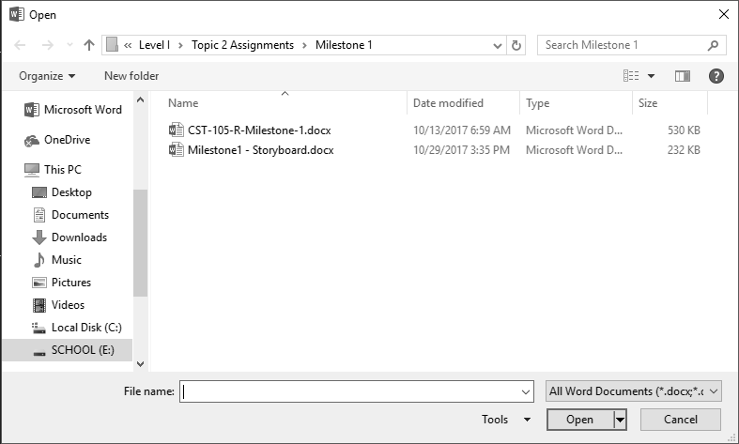

Last First | Team

Last First | Team

Last First | Team

Last First | Team

Last First | Team

Click a checkbox to remove players from your list